**ME 111 Engineering Drawing: July-Nov 2017**

**Indian Institute of Technology Guwahati**

**Lab-2 [KEY] Engineering Curves Monday Forenoon Batch**

1. Draw a hyperbola of e = 3/2 if the distance of the focus from the directrix is 50 mm.

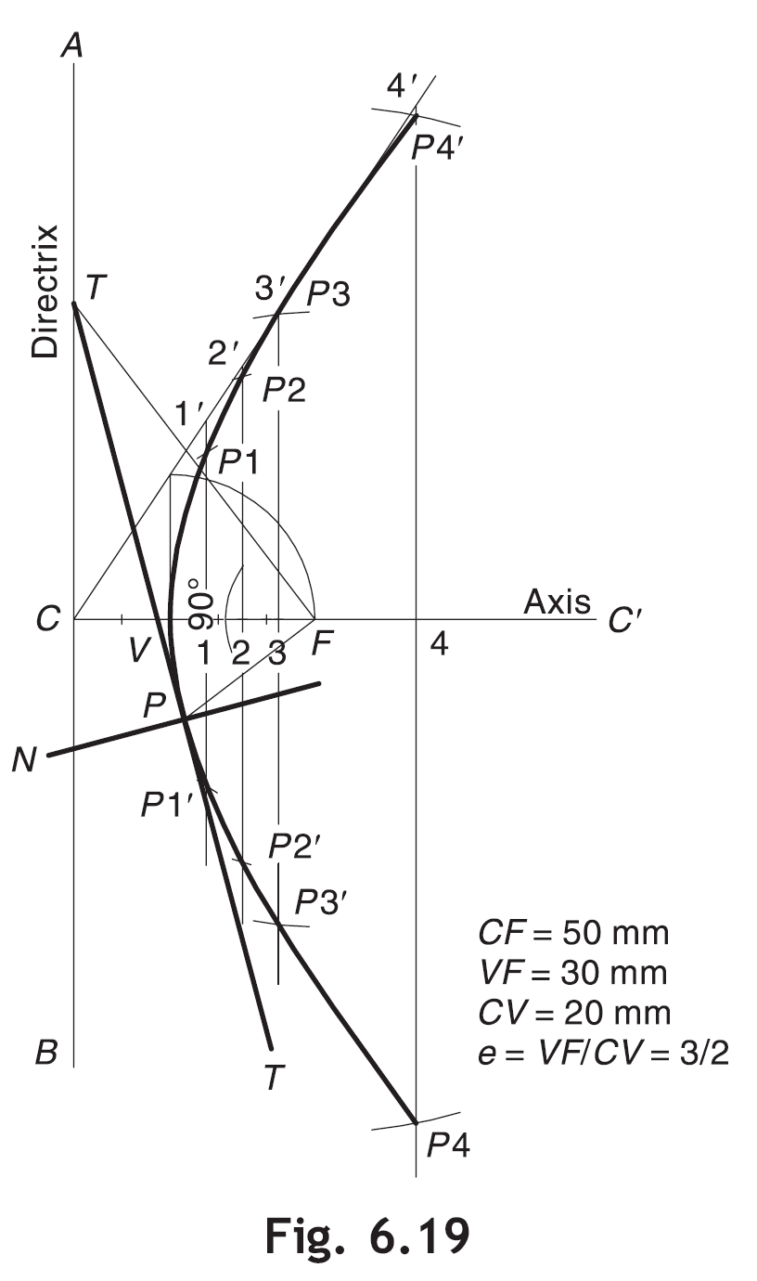

1. A fixed point F is 50 mm from a fixed straight line. Draw the locus of a point P moving in such a way that its distance from the fixed straight line is 3/2 times its distance from F.

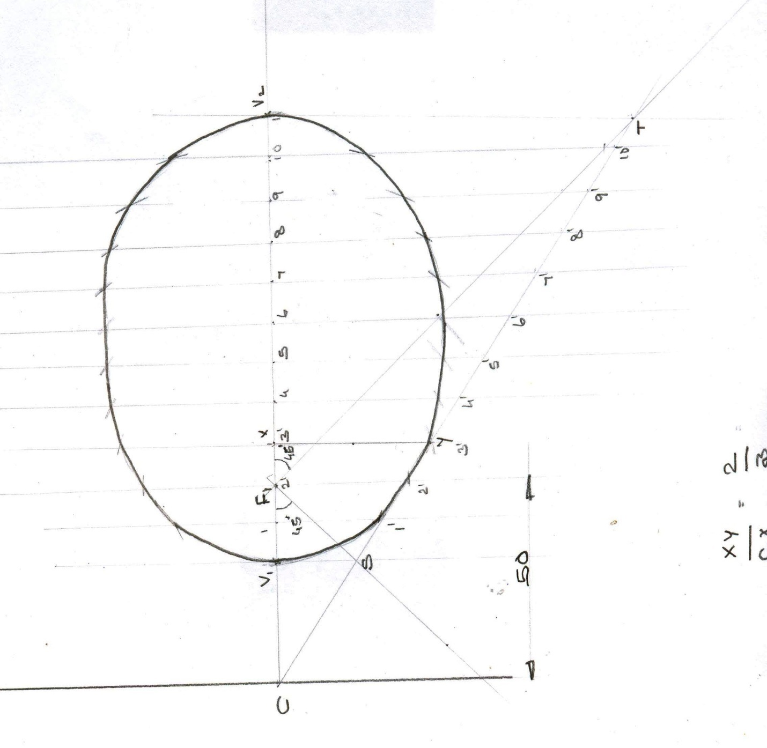

1. Draw locus of a point on the periphery of a circle which rolls from the inside of a curved path. Take diameter of rolling circle 60 mm and radius of directing circle (curved path) 85 mm.

